Site A – Hobbytown
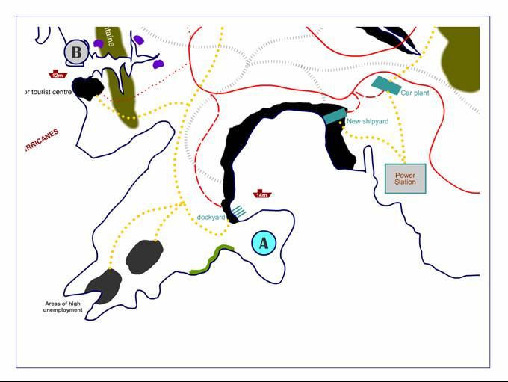

Site
Port
Road & rail links
Power
Workforce
Market
Environment
Economic
Site B – Prettyville
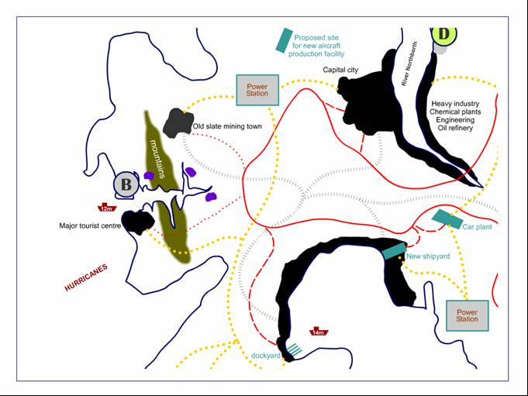

Site
Port
Road & rail links
Power
Workforce
Market
Environment
Economic
Site C – Old smoky villages
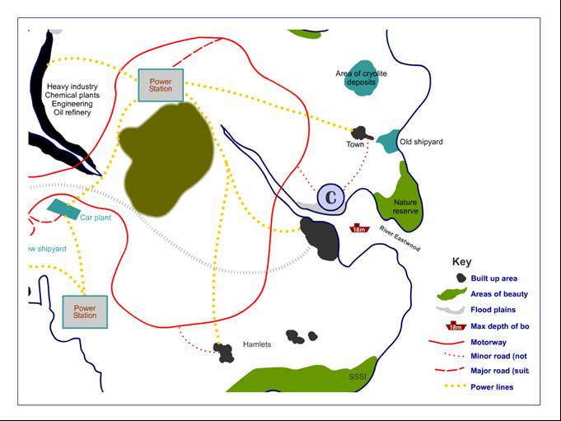

Site
Port
Road & rail links
Power
Workforce
Market
Environment
Economic
Site D – Smellyville
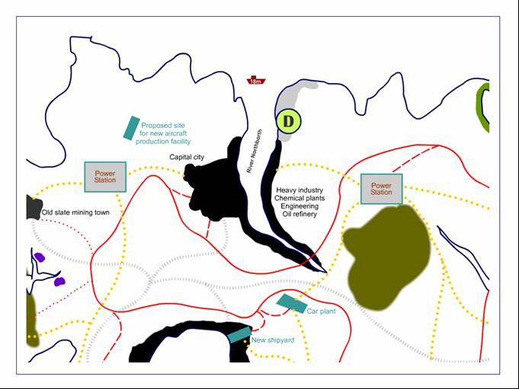

Site
Port
Road & rail links
Power
Workforce
Market
Environment
Economic
Site E – Quietsomers
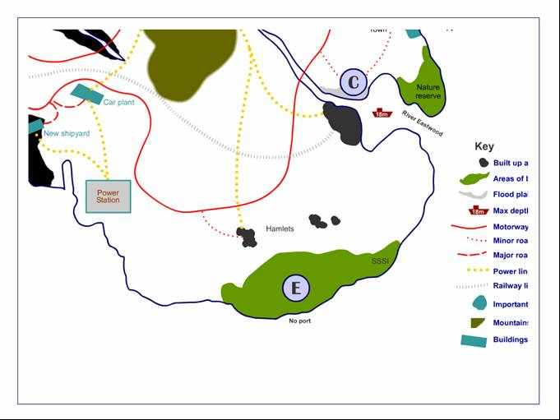
Site
Port
Road & rail links
Power
Workforce
Market
Environment
Economic

